**Project Overview:**

* The project will be about creating a web application for a greengrocery store.
* The applications will enable users/customers to conduct transaction by purchasing vegetables or fruits from our website and having the purchases delivered to their doorsteps.

**Technical Approach/Project Implementation**

* To implement the above project, I will need to install a lamp onto the pi to act as a web server so that I could all user information onto my database.
* The project will use html, php for the front-end of the website and MySQL for the back-end.
* The database will keep track of the users contact information, bank card information and the transactions involved.

**Website Wireframe**

* Note:(For Visual purposes) Not exact wireframe. But the structure will follow this format.

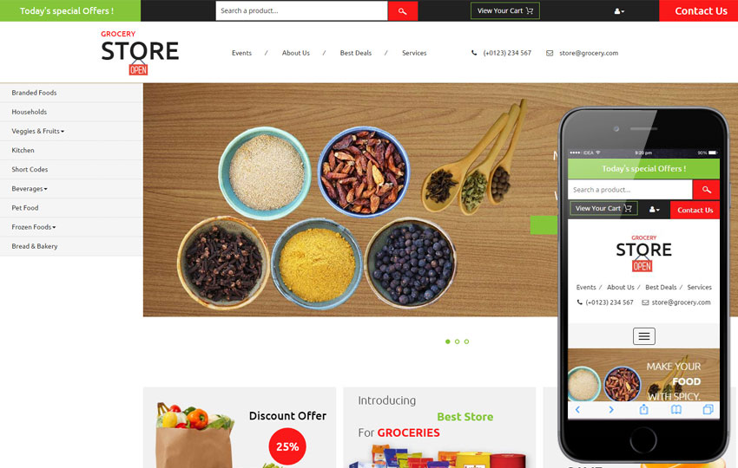

**Significance of the Project/Problems it solves**

* The website enables users to purchase groceries and having them delivered to there doorstep without them having to go to an actual grocery
* The website helps reduce congestion at green groceries since customers can order online
* Helps customers who don’t have the transportation means to go to a green grocery.

**Milestones:**

* Project schedule Plan
* Install lamp on pi- Nov 17
* Create home and about page-Nov 24
* Create register and login page Dec 1
* Create fruits, vegetable page, bank Info page -Dec 8
* Handling the backend database-Dec 15

**References:**

* Google wireframe image sample- <https://www.google.com/search?q=school+grocery+web+app+projects&tbm=isch&source=iu&ictx=1&fir=0h82RxZBqE1bVM%253A%252Cs7QQwmdHzwoKOM%252C_&usg=AI4_-kRcvcJ16PDTcjdi7RlXxWBThtl16g&sa=X&ved=2ahUKEwjsmajd1b3eAhUs4oMKHd8pDB0Q9QEwAHoECAEQBA#imgrc=Q2SVr_dcrkiO3M>:
* Bootstrap:- <https://getbootstrap.com/docs/4.0/components/forms>
* Php Manual-

http://php.net/manual/en/index.php